Mutchumari Chandrasekhar Reddy: AP25110010976

1. Implement a hash table using Linear Probing
Program:
#include<stdio.h>
#define SIZE 10
int main(){
int hash[SIZE],n,key,i,index;
for(i=0;i<SIZE;i++)
hash[i]=-1;
printf("Enter number of elements: ");
scanf("%d",&n);
printf("Enter elements:\n");
for(i=0;i<n;i++){
scanf("%d",&key);
index=key%SIZE;
while(hash[index]!=-1)
index=(index+1)%SIZE;
hash[index]=key;
}
printf("Hash Table:\n");
for(i=0;i<SIZE;i++)
printf("%d : %d\n",i,hash[i]);
return 0;
}

Terminal Process:
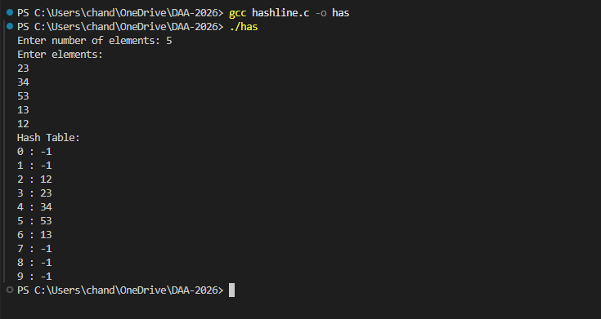
2. Implement a hash table using Quadratic Probing
Program:
#include<stdio.h>
#define SIZE 10
int main(){
int hash[SIZE],n,key,i,index,j;
for(i=0;i<SIZE;i++)
hash[i]=-1;
printf("Enter number of elements: ");
scanf("%d",&n);
printf("Enter elements:\n");
for(i=0;i<n;i++){
scanf("%d",&key);
index=key%SIZE;
j=0;
while(hash[(index+j*j)%SIZE]!=-1)
j++;
hash[(index+j*j)%SIZE]=key;
}
printf("Hash Table:\n");
for(i=0;i<SIZE;i++)
printf("%d : %d\n",i,hash[i]);
return 0;
}
Terminal Process:
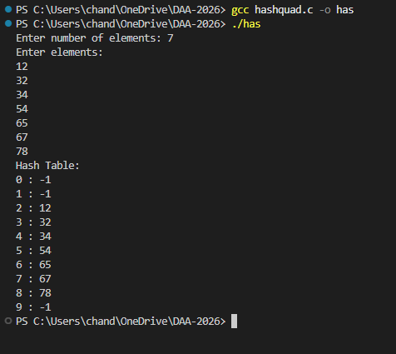
3. Given an array and a target value T, determine whether there are two elements whose sum is equal to T. (Average Time Complexity should be O(n)

Program:
#include<stdio.h>
#define SIZE 100
int main(){
int a[SIZE],hash[SIZE],n,T,i,index,j,found=0;
for(i=0;i<SIZE;i++)
hash[i]=-1;
printf("Enter number of elements: ");
scanf("%d",&n);
printf("Enter elements:\n");
for(i=0;i<n;i++)
scanf("%d",&a[i]);
printf("Enter target value: ");
scanf("%d",&T);
for(i=0;i<n;i++){
index=(T-a[i])%SIZE;
if(index<0)
index+=SIZE;
j=0;
while(hash[(index+j)%SIZE]!=-1){
if(hash[(index+j)%SIZE]==T-a[i]){
found=1;
break;
}
j++;
}
if(found){
printf("Two elements are %d and %d\n",T-a[i],a[i]);
break;
}
index=a[i]%SIZE;
if(index<0)
index+=SIZE;
j=0;
while(hash[(index+j)%SIZE]!=-1)
j++;
hash[(index+j)%SIZE]=a[i];
}
if(!found)
printf("No two elements have sum equal to %d\n",T);
return 0;
}
Terminal Process:
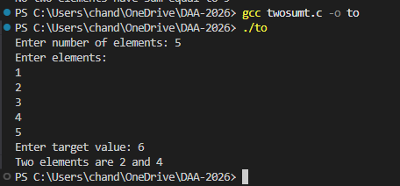

4. Given an integer array, use hashing to find the frequency of every distinct element.
Program:
#include<stdio.h>
#define SIZE 100
int main(){
int a[SIZE],hash[SIZE],freq[SIZE],n,i,key,index,j;
for(i=0;i<SIZE;i++){
hash[i]=-1;
freq[i]=0;
}
printf("Enter number of elements: ");
scanf("%d",&n);
printf("Enter elements:\n");
for(i=0;i<n;i++){
scanf("%d",&key);
index=key%SIZE;
if(index<0)
index+=SIZE;
j=0;
while(hash[(index+j)%SIZE]!=-1&&hash[(index+j)%SIZE]!=key)
j++;
if(hash[(index+j)%SIZE]==-1)
hash[(index+j)%SIZE]=key;
freq[(index+j)%SIZE]++;
}
printf("Frequency of elements:\n");
for(i=0;i<SIZE;i++)
if(hash[i]!=-1)
printf("%d : %d\n",hash[i],freq[i]);
return 0;
}
Terminal Process:
